**GENERAL HUMAN BIOLOGY – YEAR 11**

**TASK 10 – Practice Test**

**NAME: _______________________________________ WEIGHTING: 10%**

**TOTAL = ______/ 51**

***MULTIPLE-CHOICE [5 MARKS]***

1. The embryo is surrounded by the amniotic cavity, filled with amniotic fluid. This fluid:
   * 1. Acts as a shock absorber
     2. Provides a medium through which the exchange of materials takes place between the mother and embryo
     3. Helps to regulate a constant temperature
     4. Produces hormones for the developing embryo

From the above list, which two (2) statements are correct about amniotic fluid?

1. i and iv only
2. ii and iii only
3. i and ii only
4. i and iii only
5. Select the INCORRECT statement. During pregnancy:
6. The embryo divides through the process of cleavage.
7. Body organs are produced from the three germ layers
8. Foetal heart starts beating during the 4th week of pregnancy
9. The arms and legs of the foetus are formed towards the end of pregnancy
10. There is a known and predictable sequence of development from the zygote through embryonic stages to foetal development which can be monitored by using ultrasound scans. Which is the correct definition a foetal blood sampling?
11. Inaudible high frequency sound waves are reflected from the developing foetus and are used to produce an image of the foetus
12. Amniotic fluid and then cells from the foetus floating in the fluid are extracted for testing and then organised so that number and length of chromosomes can be compared.
13. The instrument is inserted through the abdomen wall into the uterus to directly observe the foetus
14. Foetal cells in the mother’s blood are separated out and then examined for chromosomal abnormalities
15. To maintain a healthy pregnancy it is suggested that pregnant women:
    1. Start/ increase level of exercise, increase intake of protein, calcium and folic acid.
    2. Decrease level of exercise, maintain current intake of protein, calcium and folic acid.
    3. Maintain current level of exercise, maintain current intake of protein, calcium and folic acid
    4. Maintain current level of exercise, increase intake of protein, calcium and folic acid
16. True or False: Prior to improved technology and understanding of the birth process, the incidence of death due to childbirth was the same as it is now.
    1. TRUE
    2. FALSE

***SHORT ANSWERS [46 MARKS]***

1. Teenagers and young adults often do not want to get pregnant and utilise a large variety of methods to prevent this occurring.
   1. Contraception methods usually fall into 1 or 3 categories, name and give an example of each (4 marks)

* 1. Spermicide is often found on condoms, explain how it assists in preventing pregnancy.

(2 marks)

* 1. Why do doctors often recommend using multiple forms of protection but not multiple condoms. (3 marks)

1. Some couples try for years to get pregnant and can’t these people are said to be infertile. Explain why GIFT is less effective than ZIFT as an ART. (3 marks)

1. Immediately following fertilisation, the zygote begins to divide to form a solid ball of cells. As cell division continues, the cells arrange themselves into a hollow ball of cells as seen in the micrograph image below:



What is the name given to this hollow ball of cells ? [1 mark]

1. The human placenta averages 22cm in length and 2-2.5cm in thickness. It typically weights 500gm. A human placenta can be seen with the umbilical cord still attached at the top:



1. Explain where the placenta forms during the early stages of pregnancy? (2 marks)

1. Describe two functions of the human placenta [2 marks]

The umbilical cord connects the foetus to the placenta. Inside the umbilical cord are two vessels – the umbilical artery and umbilical vein.

1. In the diagram below draw the direction that blood flows through these two vessels between the foetus and the placenta. [2 marks]

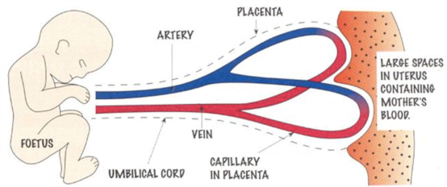

1. Arteries are often said to carry oxygenated blood and veins deoxygenated blood, however, this is not true for a foetus during development. Fix the above statement to explain blood transfer in utero. [2 marks]

1. Put the following statements into the correct order based on what month they occur in; in relation to development and changes during pregnancy. They are already in the correct trimester. [6 MARKS]

|  |  |  |  |  |
| --- | --- | --- | --- | --- |
| **TRIMESTER** | **MONTH** |  |  | **STATEMENTS** |
| **FIRST** | 1 |  | **a.** | Limb buds form and heart begins to pump. By end of this month considered a foetus. |
| 2 |  | **b.** | Division of cell to form blastocyst. Implantation into uterine wall. Formation of placenta. |
| 3 |  | **c.** | Webbed fingers and toes with nails. Forelimbs well developed from limb buds. |
| **SECOND** | 4 |  | **d.** | Rapid eye movement (dreaming), eyelids can open. Responds to sounds. Teeth buds form. High chance of survival if premature. |
| 5 |  | **e.** | Fine hair growth on body, brain increases in complexity, retina (eye) layers develop. Gripping reflexes as hands developed. |
| 6 |  | **f.** | Fingerprints evident as hands and arms developed. Reproductive organs have developed so can determine sex. |
| **THIRD** | 7 |  | **g.** | Fat layers added. Due to eyelids and lashes can determine between light and dark. All systems functional except respiratory. |
| 8 |  | **h.** | Ears adapt to sounds. Lungs and digestive system fully develops. Firm hand grasp and increased hormones for labour. |
| 9 |  | **i.** | Lungs mature with alveoli development. Lots of movement and more fat added. Growth slows down. |

1. The diagram below shows an example of a pregnancy condition known as placenta previa compared with a normal progressing pregnancy:

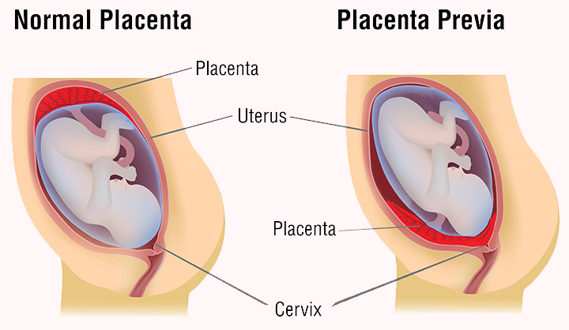

A woman with placenta previa requires a cesarean section to ensure healthy delivery of the baby. A cesarean section involves an incision made through the abdominal wall and uterus, allowing the baby to be removed from the mother.

* 1. Explain the consequences of placenta previa for both mother and feotus. (4 marks)

* 1. The birth of a child can be summarised into the three stages of labour. In the table below, include the major events that occur in each of the stages. [3 marks]

|  |  |
| --- | --- |
| **STAGE** | **EVENT** |
| 1. **Dilation** |  |
| 1. **Expulsion** |  |
| 1. **Placental** |  |

* 1. Explain which stage is the riskiest during the birthing process. (2 marks)

* 1. An ectopic pregnancy is where the fertilised egg does not implant itself into the uterine wall. This results in the pregnancy being terminated either naturally (due to incorrect growing conditions) or by medical intervention. Why would an ectopic pregnancy not allow for the growth and development of a fertilised egg? (3 marks)

1. During pregnancy a single cell (ovum) undergoes division to form millions of cells.
   1. What form of cell division does the zygote go through to increase its number of cells and grow? (1 mark)

* 1. As a zygote (fertilised egg) continues to develop and mature during pregnancy, the name given to it changes. What are two other names used during pregnancy for the developing unborn child? (2 marks)

1. State one teratogen and explain the effect it has on an unborn child (4 marks)